
______________________________________________________________________________

Board Meeting Agenda
Date: Monday, November 18, 2024
Time: 6:30 PM
Via Zoom:
https://canyonsonline.zoom.us/j/85718538119?pwd=eHlqVFI0WkhXMmJFc3dpUGVzZFl3QT09

Call to Order / Pledge of Allegiance
Approval of Current Agenda
Approval of Minutes (Oct 21, 2024)

Board Reports:
President adwcpresident@gmail.com Kat Hupp – no report
Vice President adwcvp@gmail.com Anne Marenco – no report
Secretary adwcsecretary@gmail.com Tracy Dulle
- I've sent one email to membership so far in November: 140 recipients, 97 opened, 17 clicks. I plan to send another one this week that covers November/December events.
Treasurer adwctreasurer@gmail.com Yvonne Shechter – no report
Facilities adwcfacilities@gmail.com Karrie DeMott
- Winds caused damage to the marquee plexiglass doors. Brett will work with Jim (Missy) to re-install and possibly add flashing along sides to help prevent wind from blowing in under doors & pushing them off. We do have another big wind event coming around 11/19/24.
- Tumbleweeds that were piled up on front fence & mound were cleaned up & put in dumpster before the Veterans Day Event.
- 11/12 - Met with Fletchers Fire Extinguishers & they re-charged & certified all 3 fire extinguishers.
Rentals adwcrentals@gmail.com Adrianna St. Pierre
- I would like to discuss blocking the days before or after an event that the ADWC is hosting so there is no pressure for setups and tear- downs. Should a 6-hour rental come up then, yes, they would get the priority. However, if there is no rental then, we would block off the dates for set up and breakdowns. I know we do that for the "bigger" events, but I would like this to be considered for ALL of them. DISCUSSION
- I was wondering for our January general meeting if we could ask the membership for help with the tables and chairs. Just to wipe them down, place them in the rack the correct way, etc. This would give us a good idea of wear and tear on the items to see if anything needs to be replaced or needs fixing. I would like to propose that we zip tie chairs to the very bottom of the rack so that they don't get moved and the stacking wouldn't be a continued issue.😅 DISCUSSION
Programs adwcprograms@gmail.com Stella Plunkett – no report
Membership adwcmembership@gmail..com Renee Bianco – no report
Editor adwceditor@gmail.com Angela Phillips
- November Newsletter went out on Nov 2nd. There were 197 recipients with 195 successful
deliveries. 143 opened the email and 46 clicked on the link to the newsletter. A number
opened it more than once creating a total of 286 opens and 59 clicks.
Media/Marketing adwcpublicity@gmail.com Missy Wilson
- Website visitors: 320
Website Impressions: 3.6K
- Facebook: 6 posts, 8 story posts, 37 public page likes, 266 reactions, 721 accounts reached, 84 shares, 16 comments
- Instagram: 6 posts, 8 story posts, 77 likes, 507 reached, 0 saves, 11 shares, 2 comments
- Twitter: 6 posts, 4 likes, 81 reached, 1 retweets, 3 comments
- Nextdoor: 6 posts, 12 likes, 0 comments, 7 faves, 1 recommendation, 25 page visits
- ADWC Instagram Posts shared by KHTS on their page (not sure if this counts as a broadcast announcement): 4
Likes: 32
Comments: 0
- ADWC Facebook Posts shared by KHTS on their page (again not sure if it counts as a broadcast announcement): 4
Likes: 20
Shares: 19
Comments: 0
- FACEBOOK:
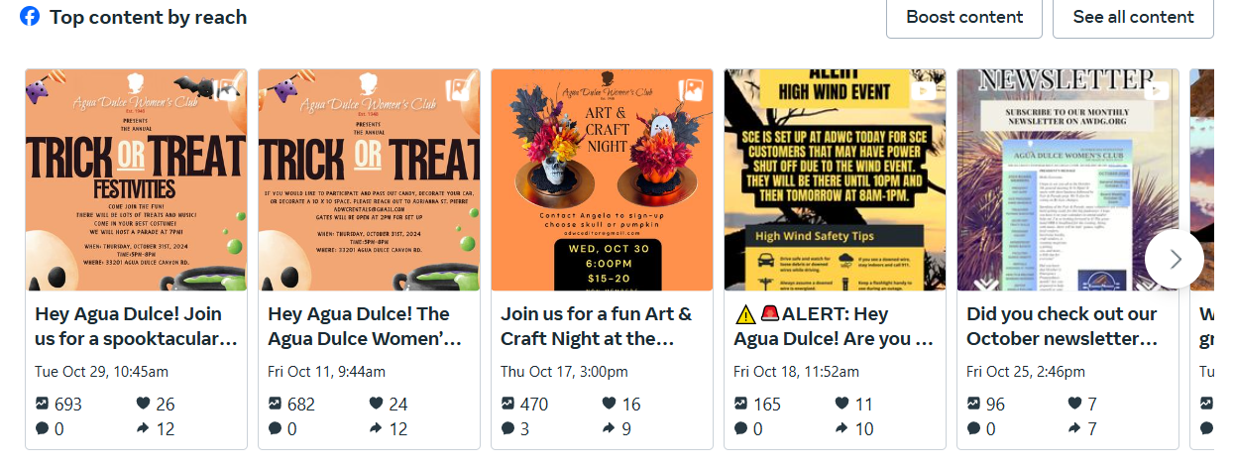
- INSTAGRAM:
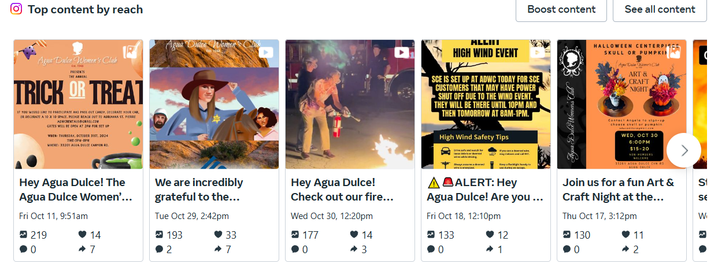
Health & Wellness adwchealth@gmail.com Barbara Bernero – no report
Events/Committees Reports/Updates:
- Monthly Art Social Program: Angela Phillips
  - The Halloween centerpiece project had 27 sign-ups. We had 4 cancellations a few days
before, but the day of the event we had an additional 7 more cancellations or no shows. For
now on I will make it clear that if they don’t show up or if they cancel the day of, they will still
have to pay the fee. I had calculated a cost of $15 per person and collected that, but with
only 18 paying it came to $17.70 a person.
- Community Collaborators Monthly Meeting: IDK
- Family Game Nights Slated for 2025: Adrianna St. Pierre
- Holiday Gift Boutique Nov 23, 9am-3pm: Charleen Mullin & Renae Rosa
  - We are going to allow some of the vendors to start setting up on Fri afternoon. Then Renae is going to be spending the night in her trailer with her husband. We are informing everybody that if they leave their stuff, their awnings must be weighted down and everything will be at their own risk. I think we have 38 vendors with a couple more that I’m waiting for applications from.
- Parade of Tables Dec 7, 10:30am: Julie White & Mary Johnson
  - Thank you to the Board for donating a free rental
- Santa’s Secret Shop Dec 15, 1-4pm: Amanda Buchan/Adele P/Debbie M/Oralia E/Angela P
  - We were all doing some shopping online and other things trying to find the most reasonable priced items for the Santa store. We've gotten a few donations from members. Some things we can use and some we will need to discard. We have a sign-up sheet that will be going out for helpers. I'll ask Tracy to send out a bulletin again asking or begging for donations of items or monetary. I would really like to see more club members be aware of what this event does for our children of our community, And the happiness in their faces when leaving with their wrapped gifts. They may be more willing to donate time, items or money. Hope the bulletin will encourage members to drop off items at the Dec meeting. We still need bags, tissue paper bows if we have 80 children coming in and if they buy four things which they usually buy more, there are over 400 items to be wrapped and of course they want everything wrapped individually. They don't like to put everything in one bag. Angela has stepped up with redoing Amazon boxes in different sizes and then wrapping the bottom and the top. This will help. Our committee is wonderful and dedicated to making this a huge success. I won't be doing too much on the ground. My pneumonia came back and I'm down and out with it. But I did find time to order some items online. I will need to submit my receipts to the club to get reimbursed before this event.
- Documents Review Committee: Anne Marenco – no update
- Election Committee: Anne Marenco – no update
- Emergency Preparedness Committee: Anne Marenco & Kat Hupp – no update
- Scholarship Committee: - Slated for Feb 2025.
- Grants Committee: Kat Hupp & Anne Marenco – no update
- Welcome Wagon Committee: Tracy Dulle & Lee Sola – no update
- Blood Drives Liaison: Adrianna St. Pierre
  - We have 16 sign-ups, out of possibly 50. I would love for us to at least get 40 sign-ups. Please share the flyer on all the Socials with the event link to register. THANK YOU! Schedule a Blood, Platelet or Plasma Donation | American Red Cross

New Business
- Santa’s Secret Shop Budget
- Spam Emails

Old Business
- Veterans Day Pancake Breakfast
  - A terrific turn-out! Approximately 60 were in attendance (not counting volunteers).
Bob McQuaid did an excellent job as Master of Ceremonies. Edwards AirForce sent the Blue Eagles Honor Guard to do the Posting of Colors and Patti Duce led us in the National
Anthem. Guest speaker was Jackie Owens, from Congressman Mike Garcia’s
representative for Veteran’s Affairs.
Committee Volunteers:
    - Angela Phillips, Chair
    - DeBoraha Townson, Co-Chair
Committee Members: Renée Bianco, Patti Duce, Heather Harris, Christine Johnson, Adele Parillo, Janet Pierson, Adrianna St. Pierre, Kym Wilkerson, Julie White, Tracy
Dulle and Carol Hudson. Volunteers were Lorna Leslie, Christina Unzueta and Anika
Johnson. DISCUSSION
- Vasquez High Carpentry Program

Action Items
- Kat: Confirm we’re getting paid by SCE for PSPS events. Completed.
- Patti/Adrianna/Karrie: Discuss Giggster after the Fair and work on filming contract.
- Angela: Make a flyer so we can start collecting veteran’s names for our website to distribute at the Veterans breakfast and at Parade of Tables.
- Missy: Get Stella set up on the Programs email.
- Adrianna/Karrie: Adjust rental contract language to include wording that in case of an emergency we can cancel a rental… as our clubhouse is used as an Emergency Response center, an act of God can override this rental contract (something like this).
- Missy/Karrie: Touch base about Santa Clarita Grocery.
- Charleen: Update boutique flyer and get it to Missy for posting.

Open Forum

Adjournment
Dates to Remember:
- Sat, Nov 23 – 10am-3pm Holiday Boutique
- Thurs, Dec 5 – 6:30pm Installation Dinner
- Sat, Dec 7 – 10:30am – Parade of Tables
- Sun, Dec 15 – 1-4pm – Santa’s Secret Shop
- Mon, Dec 16 – 6:30pm 2024/2025 Board Meeting (in person)

